Project Planning Phase

Project Planning Template (Product Backlog, Sprint Planning, Stories, Story Points)
Date: 28 February 2026
Team ID: LTVIP2026TMIDS60852
Project Name: Dream Nest – House Rent, Vacation & Villa Booking Platform
Maximum Marks: 5 Marks

Product Backlog & Sprint Schedule
Sprint | Functional Requirement (Epic) | User Story No | User Story / Task | Story Points | Priority | Team Members
Sprint-1 | Backend Setup | USN-1 | Setup Node.js server, MongoDB connection, and environment configuration. | 5 | High | All Members
Sprint-1 | Authentication Module | USN-2 | Implement secure signup/login using JWT & Bcrypt. | 5 | High | Backend Team
Sprint-1 | Schema Design | USN-3 | Create User, Listing, and Booking Mongoose schemas. | 3 | High | Database Team
Sprint-2 | Listing Management | USN-4 | Create property listing form with image upload & drag-drop feature. | 5 | High | Frontend + Backend
Sprint-2 | Search & Filtering | USN-5 | Implement category filtering & keyword search functionality. | 5 | Medium | Frontend Team
Sprint-3 | Booking System | USN-6 | Develop calendar-based booking and reservation management. | 5 | High | Backend Team
Sprint-3 | Wishlist & Redux | USN-7 | Implement add/remove wishlist using Redux state management. | 3 | Medium | Frontend Team
Sprint-4 | UI Enhancement | USN-8 | Enhance UI using SCSS & Material UI for responsiveness. | 3 | Medium | Frontend Team

Project Tracker, Velocity & Sprint Details
Sprint | Total Story Points | Duration | Start Date | End Date (Planned) | Story Points Completed | Release Date
Sprint-1 | 13 | 7 Days | 01 Feb 2026 | 07 Feb 2026 | 13 | 07 Feb 2026
Sprint-2 | 10 | 7 Days | 08 Feb 2026 | 14 Feb 2026 | 10 | 14 Feb 2026
Sprint-3 | 8 | 7 Days | 15 Feb 2026 | 21 Feb 2026 | 8 | 21 Feb 2026
Sprint-4 | 3 | 5 Days | 22 Feb 2026 | 27 Feb 2026 | 3 | 27 Feb 2026

Velocity Calculation
Total Story Points = 13 + 10 + 8 + 3 = 34
Number of Sprints = 4
Velocity = 34 / 4 = 8.5 Story Points per Sprint

Burndown Chart
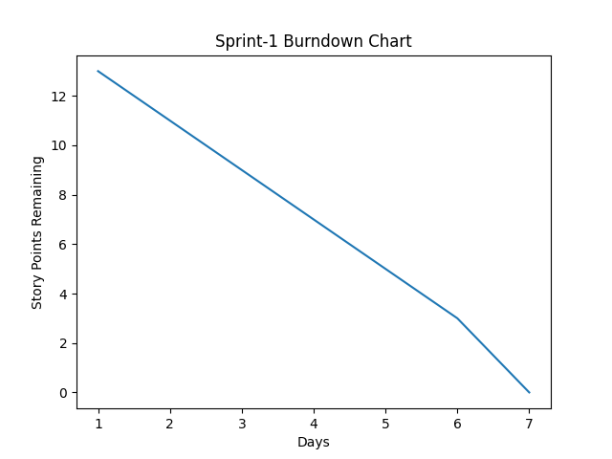
The burndown chart represents the remaining work over time during Sprint-1. It helps monitor progress and ensures timely completion of planned tasks.

